In this video we will learn about the commonly used built-in string functions in SQL server and finally, a real time example of using string functions. Please watch the following videos, before continuing with this video.  
[Part 11 – Group By](http://csharp-video-tutorials.blogspot.com/2012/08/group-by-part-11.html)  
[Part 22 – Built in string functions](http://csharp-video-tutorials.blogspot.com/2012/08/built-in-string-functions-in-sql-server.html)  
  
   
  
   
  
   
  
**LEFT**(Character_Expression, Integer_Expression) - Returns the specified number of characters from the left hand side of the given character expression.  
  
**Example**: Select LEFT('ABCDE', 3)  
**Output**: ABC  
  
**RIGHT**(Character_Expression, Integer_Expression) - Returns the specified number of characters from the right hand side of the given character expression.  
  
**Example**: Select RIGHT('ABCDE', 3)  
**Output**: CDE  
  
**CHARINDEX**('Expression_To_Find', 'Expression_To_Search', 'Start_Location') - Returns the starting position of the specified expression in a character string. Start_Location parameter is optional.  
  
**Example**: In this example, we get the starting position of '@' character in the email string 'sara@aaa.com'.   
Select CHARINDEX('@','sara@aaa.com',1)  
**Output**: 5  
  
**SUBSTRING**('Expression', 'Start', 'Length') - As the name, suggests, this function returns substring (part of the string), from the given expression. You specify the starting location using the 'start' parameter and the number of characters in the substring using 'Length' parameter. All the 3 parameters are mandatory.  
  
**Example**: Display just the domain part of the given email 'John@bbb.com'.  
Select SUBSTRING('John@bbb.com',6, 7)  
**Output**: bbb.com  
  
In the above example, we have hardcoded the starting position and the length parameters. Instead of hardcoding we can dynamically retrieve them using CHARINDEX() and LEN() string functions as shown below.  
  
**Example**:  
Select SUBSTRING('John@bbb.com',(CHARINDEX('@', 'John@bbb.com') + 1), (LEN('John@bbb.com') - CHARINDEX('@','John@bbb.com')))  
**Output**: bbb.com  
  
Real time example, where we can use LEN(), CHARINDEX() and SUBSTRING() functions. Let us assume we have table as shown below.   
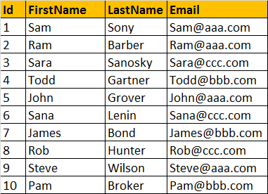  
  
Write a query to find out total number of emails, by domain. The result of the query should be as shown below.   
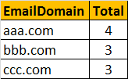  
  
**Query**  
Select SUBSTRING(Email, CHARINDEX('@', Email) + 1,  
LEN(Email) - CHARINDEX('@', Email)) as EmailDomain,  
COUNT(Email) as Total  
from tblEmployee  
Group By SUBSTRING(Email, CHARINDEX('@', Email) + 1,  
LEN(Email) - CHARINDEX('@', Email))

[Email This](https://draft.blogger.com/share-post.g?blogID=6082652835152798567&postID=7194138256811967557&target=email)[BlogThis!](https://draft.blogger.com/share-post.g?blogID=6082652835152798567&postID=7194138256811967557&target=blog)